**HungerMate Feature 1 User Guide**

**By:**

**Christopher Mendoza**

**Haricharan Mukthineni**

**Gabriel Braun**

**For:**

**SWEN 5239.32 Agile Software Development**

**Dr. Soma Datta**

**April 14th, 2024**

**Contents**

Main Menu………………………………………………………………………………………………2

Filter Restaurants Menu……………………………………………………………………………….3

**Main Menu**

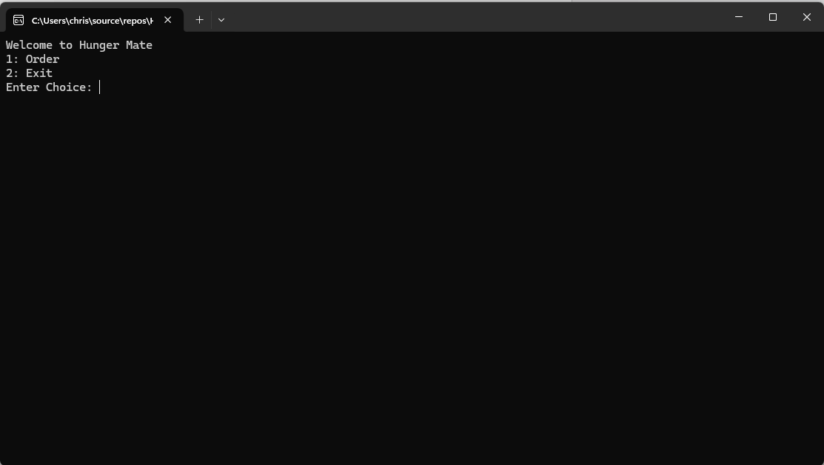

The main menu allows the user to input whether they are ready to place and order or exit the application.

**Restaurant Filter Menu**

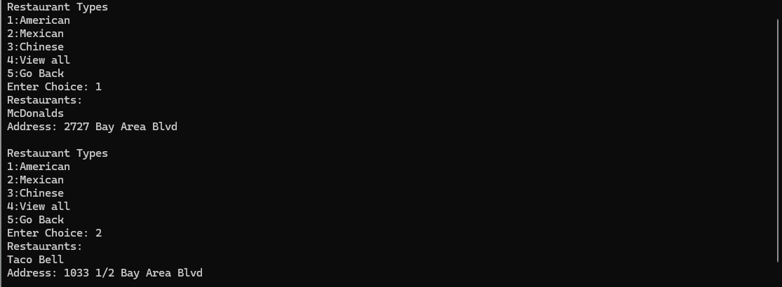

The Restaurant Filter menu allows the user to select the type of cuisine they are looking for and the application will print the restaurants of that type. The user can also select to view all restaurants or to go back to the main menu.